READER

**PROFESSIONAL COUNSELLING**

1 Counselling as a systematic approach 1

2 Problem-based learning 2

2.1 Case Studies 3

2.1.1 Case Anna: Strategic issues in a digital world 3

2.1.2 Case Fatima: Digital transformation in an ageing SME 5

2.1.3 Case Imara: Experienced leader and digital challenges 7

2.1.4 Case Sophia: Up-and-coming talent with choices 9

2.2 Scientific approach 11

2.3 Practical approach 12

3 Discussion Task: Column 13

References 15

* 1. Counselling as a systematic approach

The focus of counselling in the sense of DIGIGEN is the personality of female managers, even regarding professional issues. This means that all dimensions of individual professionalism are to be included.

Beck (2019, p. 24 ff.) characterises these central personality traits based on six “activity-accompanying metacognitions of professionalism”:

* **Relevance cognition** is the individual’s perception that one’s occupation is so significant that third parties are willing to pay a wage for it that ensures a livelihood (“socially significant” and “necessary for subsistence”).
* **Time cognition refers to** the proportion of time a person allocates to their occupation in their annual and lifetime budgets. This share must be substantial in terms of scope and duration.
* **Competence cognition**,as an essential part of the self-concept, is directed towards one’s own cognitive, affective and psychomotor performance possibilities and the disposition and motivation necessary for this.
* **Ideal cognition** refers to the awareness of individually binding standards for the evaluation of one’s own professional activity. This also includes a sense of tolerance towards one’s own mistakes or deficits.
* **Status cognition** enables the individual to determine their position in the social environment, such as the company hierarchy or in the work team. This cognition is important for job satisfaction, the ability to work in a team, the willingness to make an effort and the need for recognition in the social context.
* The **cognition of meaning** forms the person’s awareness to contribute to the community through their professional activity. This - in conjunction with a moral self-expectation - can feed a sustainable motivation for activity.
  1. Problem-based learning

**Your task** for topic 5 of the up-skilling programme is to explore and create counselling settings for four different cases (case studies) based on practical and scientific counselling approaches and your own experience. To do so, please use the presentations on scientific and practical approaches together with the information in the problem-based learning (PBL) library. Your trainer will explain PBL; if you are interested in literature on PBL, please check [Melnyk et al. (2010)](https://download.lww.com/wolterskluwer_vitalstream_com/PermaLink/NCNJ/A/NCNJ_165_516_2010_08_23_DGSODKGNM_1651_SDC516.pdf).

* + 1. Case Studies

There are four cases, varying in their context, which you will work with.

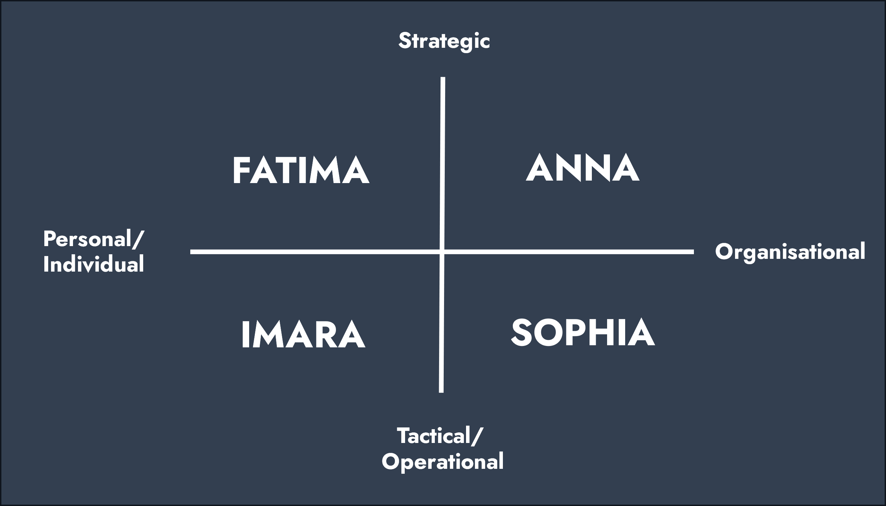

Figure 1: Balanced scorecard with four cases.

* + - 1. Case Anna: Strategic issues in a digital world

**Professional**

You work as a Consultant Management & Change at a consultancy firm that offers (executive) coaching and mentoring programs. The department in which you work specialises in leadership development of people in top positions.

As a Consultant Management & Change, you are involved in designing, implementing and supervising change, leadership and team interventions. You support CEOs in implementing new strategies and increasing change among all employees of the organisation. In your coaching, you always focus on the whole person, personal growth and development, both work-related and other areas of life.

**Issue**

You have received an email from one of the CEOs, Anna (40+). Anna is a successful businesswoman and runs a large technology company in ICT and software development called DigitalTech. She has worked hard to achieve her position as CEO. She realises that Artificial Intelligence significantly impacts her company and her employees. She wants to exchange ideas with you about her vision, how she can implement the desired change processes, and what possibilities she can personally tap into in her way of leading.

DigitalTech is a company that specialises in developing innovative digital solutions for customers worldwide. They have built a reputation for delivering high-quality products and services. Still, the digital world is constantly changing and there are always strategic issues that Anna and her team face.

One of these issues is the rise of artificial intelligence (AI) and its impact on the DigitalTech market. Anna and her team are aware that AI has the potential to change the way businesses operate dramatically. They know that if they don’t keep up with this technological shift, DigitalTech could potentially fall behind and lose competitive advantage.

However, Anna is reluctant to take the AI direction even though her team convinces her of its necessity. She doubts her ability to make the right strategic decisions. She wonders if she has enough knowledge of AI and if she is the right person to lead the company in this new direction. She seems afraid that others will discover that she is actually not competent enough for her leadership role.

In addition, Anna notices that some of her male colleagues within DigitalTech seem to be more confident in making strategic decisions regarding AI. She feels intimidated and wonders if she will be taken seriously if she expresses her concerns and doubts. This reinforces her feelings of insecurity and makes it even harder for her to act.

Anna wonders what direction she wants to take in her career. Although she is thriving as CEO of DigitalTech, she sometimes feels inner turmoil and wonders if this really is where she wants to be.

Anna has always had a passion for social impact and sustainability. She has often wondered if she can use her knowledge and leadership skills to change the world positively. This puts her in a dichotomy between continuing to lead DigitalTech and exploring new possibilities. She has considered setting up a new company focusing on sustainable technologies and innovations.

Her career question adds even more complexity to Anna’s struggle with her current leadership position and the strategic challenges she faces. She wonders if her desire for a different career direction stems from the uncertainty about suitability for her current position or if it’s really a deep-seated desire to mean more in another area.

**Career question**

You wonder what you can do for Anna and how you should approach and empower her to help her clear her vision, her ways of implementing the change process as a leader, and her consideration about her career process.

You will investigate relevant methodical models and approaches that may apply (see library). You intend to make a well-considered choice for an approach to the case to be able to justify it adequately for yourself and Anna.

* + - 1. Case Fatima: Digital transformation in an ageing SME

**Professional**

You work as an HR consultant at an advisory organisation, specialised in HR services for Small and Medium-sized Enterprises (SMEs). They provide support to entrepreneurs and leaders in implementing effective personnel policies. Your role involves assisting in the development of workforce planning, ensuring that your client’s employees align with the company’s future plans that have procured your services. You have a conversation with Fatima, who presents you with the following issue.

**Issue**

Fatima (40), an energetic and driven female leader, is the operational manager of an SME manufacturing company facing the challenges of digitalisation. The company has been producing traditional goods for years, but the market is rapidly changing due to new technologies and digital advancements. Fatima realises that digital transformation is crucial to keep the company competitive in the rapidly evolving market. She sees opportunities to increase productivity, reduce costs, and capitalise on new prospects by implementing modern technologies and processes. With these opportunities, the employees’ work will undergo changes. For example:

* + - Machine operators: With the introduction of automated production machines, machine operators need to learn how to operate the new automated systems and focus on monitoring the machines and troubleshooting any technical issues.
    - Logistics personnel: With automated systems for inventory management, warehouse management, and order processing, logistics personnel need to learn how to work with these systems and focus on optimising logistics processes and managing the supply chain.
    - Technicians and maintenance staff: With predictive maintenance, technicians and maintenance staff can focus on working with diagnostic tools and understanding the technologies used in the production processes.

Fatima has ambitious plans to transform and modernise the company, but she notices significant resistance from her employees towards these changes. The workforce of the manufacturing and logistics department consists mainly of older employees who have been with the company for many years. They have built valuable expertise but struggle with technologies and digital solutions. These employees have been working according to traditional methods for years and are less familiar with the possibilities and benefits of digital technologies. They strongly prefer the familiar way of working and are hesitant to embrace new technologies.

Fatima encounters the following obstacles:

* + - Lack of digital skills: Many older employees have limited knowledge and experience with digital techniques. They feel overwhelmed by their complexity and fear that they cannot effectively use new technologies. Some feel threatened by the idea that digital technology can replace traditional tasks.
    - Fear of change: The staff tends to cling to the existing work methods because they feel comfortable with familiar routines. They fear the unknown and worry that introducing digital technologies will increase their workload or even render their jobs obsolete. As a result, they approach Fatima’s proposed changes with scepticism.
    - Communication and engagement: Fatima struggles to communicate her vision for digital transformation to her staff effectively. She has noticed a lack of open communication and engagement, leading to misunderstandings and resistance. The staff does not feel sufficiently involved in the decision-making process and feels their input is not valued.
    - Generation gap: There is a generation gap between Fatima and the ageing workforce. She has a different mindset and has grown up with digital technologies. The older employees, on the other hand, have different priorities and values and may not see the necessity of digitalisation in the same way as Fatima.

Nonetheless, Fatima believes the key to success lies in engaging and involving her employees in this change. Fatima understands that resistance does not stem from unwillingness but rather from uncertainty, fear of change, and a sense that their skills and experience may no longer be relevant.

Fatima sought help and coaching from an HR consulting organisation to address this challenge. She wants to develop strategies to motivate her employees, update their knowledge and skills, and instil confidence in digital transformation. She aims to ensure that they understand that their experience is invaluable and that they play an essential role in the company’s success, even in the digital age.

With the help of HR coaching, Fatima hopes to enhance her leadership skills and find suitable approaches to get her employees on board with the digital transformation. She is determined to create an inclusive and supportive environment where everyone can grow and contribute to the company’s future. She understands that her role as a leader is not only to drive the transformation but also to inspire and support her employees throughout the journey.

**Career question**

How can Fatima overcome the aforementioned challenges and succeed in digital transformation, thereby giving her career a strong boost and being successful in her leadership role?

* + - 1. Case Imara: Experienced leader and digital challenges

**Professional**

You are an HR advisor at a large retail company. You work for multiple departments and primarily interact with managers who oversee dozens of retail employees. One of these managers is Imara. Imara has been with the company for about 30 years, with 15 years of experience as a manager. She has risen to become the manager of the Finance & Administration department. Like her fellow managers, Imara is responsible for handling personnel tasks. You have known Imara for many years and greatly appreciate her.

In recent years, the company has made significant strides in digitalisation. Competition has increased, and customers expect more digital solutions, such as online shopping, automated customer service, and data analysis. The senior management team has decided to embrace digitalisation as a strategic priority. This strategic priority now also affects the staff departments, including Imara’s department. As an HR advisor, you support Imara through the digital transformation.

**Issue**

Imara (50+) has years of experience in her field. She has recently been tasked with digitising the department, as almost all financial processes are still on paper. The cabinets in the department are overflowing with files and documents, and important pieces are frequently lost. The CEO aims to transition to a fully digital system where all data can be securely processed and stored.

However, Imara is not well-informed about the latest developments in digitalisation and struggles to understand its benefits. This has resulted in a lack of confidence in digital solutions and doubts about her own capabilities as a leader. Imara is accustomed to working traditionally, relying heavily on personal communication, paper documents, and physical meetings. She has always strongly preferred direct interaction with her team members and other stakeholders. She views digitalisation as something complex and overwhelming because she lacks the necessary skills and knowledge to effectively utilise digital tools and systems.

Imara feels overwhelmed and uncertain about this change. She has the impression that she cannot meet the expectations that come with the digital transformation of her department. She is unsure about her ability to guide and motivate her team in this new digital environment. She fears that her lack of knowledge and understanding of digitalisation might jeopardise her own position as a leader.

Despite her own hesitation and doubts, Imara is highly regarded by her team. They enjoy her leadership and respect her experience and insights. The team Imara leads consists of dedicated and experienced employees. They have worked with Imara for many years and appreciate her leadership style based on direct communication and personal interaction. The team is also reluctant regarding the digitalisation the company wants to implement. They feel uncertain about the changes that digitalisation brings and are sceptical about its benefits. They also see Imara struggling with digitalisation and doubting her own competencies, which concerns them. While the team supports and values Imara, they need more clarity and guidance regarding digitalisation. They want to understand why the company is making these changes and what it means for them. They feel uncertain about the digital transformation and the impasse that has arisen.

Imara hopes that HRM can help her develop the necessary digital skills and increase her confidence in digital solutions. She wants to understand how to guide and motivate her team during the digital transition and how to leverage the benefits of digitalisation while minimising risks. Additionally, she hopes to gain insight into her own career path and discover if she can embrace the challenges of digitalisation. Imara hopes that with the right guidance and support, she can regain her self-confidence, overcome her fears, and make the digital transformation of the Finance department a success.

However, what Imara finds challenging to share with the HR professional, but does so in good faith, is her fear of being judged or perceived as inadequate due to her lack of digital skills. She worries that admitting her struggles with digitalisation may affect her reputation and career prospects within the company. Additionally, Imara feels vulnerable in expressing her uncertainties and fears about leading her team through the digital transformation. Imara questions whether she is the right person for this task and has even considered looking for a new job. However, this also raises uncertainties: what about the limitations of finding a new job that comes with her age?

**Career question**

Am I the right person for this job? Can I and my team learn to embrace digital transformation, or do I need to look further? And in the latter case, what about the limitations of finding a new job that comes with my age?

This case illustrates the challenges an experienced leader can face when struggling to embrace new developments in digitalisation. It emphasises the importance of lifelong learning and adapting leadership styles to changing environments. It highlights the need for leaders to be open to acquiring new skills and knowledge and seek support and guidance to navigate through technological advancements. It also underscores the significance of creating a supportive, inclusive culture that encourages continuous learning and growth for leaders and their teams.

* + - 1. Case Sophia: Up-and-coming talent with choices

**Professional**

As a Learning & development consultant, you are involved in the Management Development Program to take the personal leadership of the managers in your organisation to a higher level. As a mentor of the mentoring program, you guide a number of “up-and-coming talents”, including Sophia. You coach high potentials in personal development, communication skills, project & process management, change management, and HR issues.

**Issue**

Sophia, 28, is a talented and ambitious project manager at Innovatech Solutions, a leading technology company. Sophia has participated in the Management Development Programme, which has allowed her to develop her leadership skills and accelerate her professional growth. She has already impressed her colleagues with her ability to successfully manage complex projects and lead her team to excellence.

Although Sophia has achieved great success in her current role, she faces a new challenge: the digital transformation of Innovatech Solutions. The company plans to change the way they do business by embracing new technologies and digital processes. This will majorly impact all aspects of the organisation, from strategy and operations to customer relations and internal systems.

Although Sophia has already achieved great success in her current position in her short career so far, she is beginning to wonder what next step she should take in her career. She faces the challenge of determining which path to follow to achieve her leadership ambitions and further growth.

Option 1: Digital transformation lead: Sophia is considering taking a leadership role in Innovatech Solutions’ digital transformation efforts. She has a strong affinity for technology and believes that her experience as a project manager can position her well to steer this process. She would have the opportunity to translate the company’s strategic vision into concrete digital initiatives and projects and to build a bridge between the technical teams and senior management. While this seems like an excellent opportunity to show her leadership, Sophia is concerned about the complexity and risk of this project and whether she has enough expertise in digital transformation. In addition, she has noticed that some colleagues are jealous of her growth and may not respond enthusiastically to her promotion to a leading role in the digital transformation.

Option 2: Specialisation in digital strategy: Instead of taking on the leading role in the company’s digital transformation, Sophia is considering specialising in digital strategy and consulting. She could aspire to a position at a management consulting firm that specialises in digital transformation. This would allow her to be involved with different organisations and help them design and implement digital strategies. Sophia sees this as an opportunity to increase her knowledge and skills in digital transformation. Still, she doubts whether she should leave Innovatech Solutions as the company has provided her with a safe and trusted environment. She is also aware of the jealousy some colleagues may feel when she leaves Innovatech Solutions for new opportunities.

Sophia has decided to seek advice from her mentor in the talent program, other senior leaders in her network, and digital transformation experts. She wants to hear their perspectives and make an informed decision about her career path, considering both the digital transformation and the jealousy of others.

**Career question**

Which path should I take to continue and boost my career while not letting the jealousy and negative talking of others cloud my judgement?

You wonder what you can do for Sophia and how you can approach and support her with her communication skills and issues in her current work situations, developing her own vision and the ways to embed the digital transformation in the team, as well as her considerations and dilemmas about her own career process.

You will investigate relevant methodical models and approaches that may apply (see library). You intend to make an informed choice for an approach to the case to be able to justify it to herself and Sophia.

* + 1. Scientific approach

Since the main theories of career development and career guidance take these metacognitions into account in different ways, holistic guidance always requires the inclusion of different object theories. Only then does the question arise as to how these theories can be translated into practical guidance action. This requires knowledge of operative theories.

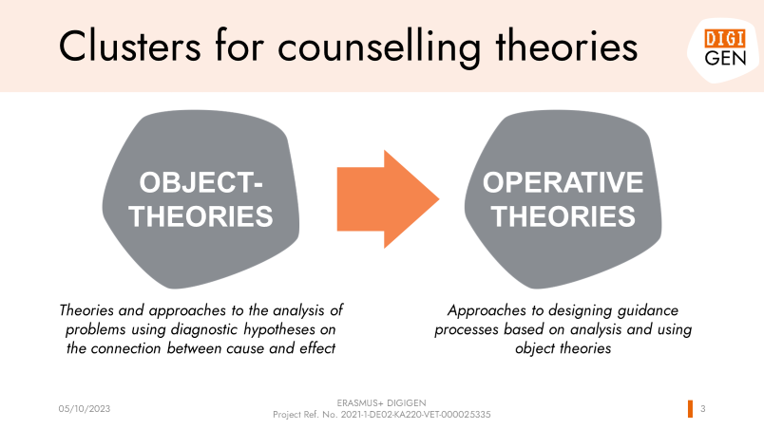

Figure 1: Relationship between object theories and operative theories.

Therefore, the library of problem-based learning contains eight psychologically oriented object theories, which are still considered fundamental to professional development today (cf. Brown, Lent 2013, pp. 29; Leung, 2008, pp. 115).

1. Holland’s personality typology approach
2. Lifelong development process of Super
3. Savickas’ constructivist view
4. Decision-making as a social learning process by Krumboltz
5. Social-cognitive career theory by Lent
6. Theory of Work Adaptation by Dawis, Lofquist and Weis
7. Protean professional career of Hall
8. Decisions as a cognitive information process

The library is supplemented by four additional scientific guidance principles from the field of **operative theories**.

1. Basics of operative counselling
2. Egan’s problem management counselling model
3. Solution-oriented consulting
4. Information Structural Counselling Methodology

The presentation *“5_PBL_Scientific Approach”* also gives a quick graphical overview of the twelve basic assumptions of the concepts presented. The presentation, therefore, serves as an introduction to familiarise oneself with the topics. If required, the readers on the explicit theories are available in the library.

For a comprehensive overview of counselling approaches and their application to different target groups, see *J.G. Maree (ed.) (2019): Handbook of Innovative Career Counselling. Wiesbaden: Springer*.

* + 1. Practical approach

The library of problem-based learning contains two **background** topics:

1. Introduction: resistance
2. Neuropsychology: how the brain works

After that, the issue of “**What is the focus of the female manager?** “is dealt with in six sections:

1. Circle of influence by Covey & Social cultural theory of cognitive development by Vygotsky
2. Mindset by Dweck
3. From Drama Triangle to Winners Triangle by Karpman
4. Influence of the undercurrent by McClelland
5. Core Qualities by Ofman
6. Stages of behavioural change by Diclemente/Prochaska

Finally, four themes deal with the **Interventions in influencing behavioural patterns**:

1. Theory U by Schramer
2. Appreciative Inquiry & Positive Psychology
3. Motivational interviewing by McClelland
4. Change language & Reframing thoughts

The presentation *“5_PBL_Practical Approach”* gives a quick graphical overview of the twelve basic assumptions of the concepts presented. The presentation, therefore, serves as an introduction to familiarise oneself with the topics. If required, the readers on the explicit theories are available in the library.

* 1. Discussion Task: Column

**COLUMN: SOCIETY IS NOT READY FOR THIS TYPE OF WOMAN LEADERSHIP**

*By Anne-Marije Buckens*

Last week I was offered a job. Not for one of the job seekers I supervise, but for myself. It happened in a packed room with employers during a lecture I gave about sustainable employability of staff. From row three, a manager shouted loudly that he had a job for me. A job ...

Not that a "job" for an entrepreneur who has been successfully running a business for more than twelve years (no, not part-time) is particularly attractive, but oh well. After the final applause, the managing director made his way to the front to reassure me that he meant business. "I need women like you in my company," he began, "women with vision, persuasiveness and an entrepreneurial view of the future." After I had thanked the managing director for the compliment and the job offer, he wanted to know where he could find "women like me".

I thought back to some of the situations that had occurred earlier in the week and told the director that they will be hard to find.

For example, I spoke to Stella (51), who had just been fired as creative director of a cosmetics brand and had started to doubt herself enormously. Her campaigns scored well and she was a good team member. She was incredibly dedicated and worked long hours. The reason for dismissal: difference of opinion with her supervisor. “I’ll tell you exactly where that difference of opinion comes from,” Stella says. “I said during a meeting that my manager repeatedly fails to meet his deadlines and that this makes my work more difficult. That is a fact and a threat to our department, but according to my supervisor, I should not have said that so straightforwardly. It would have put him in a bad light. A week later I got the receipt. Maybe I shouldn’t be so outspoken anymore.”

Intern Joy (19) withdrew as president of the student council because fellow students had said that she had a lot of hair on her teeth. Because Joy wants to fit in well with the group, she decided to hand over her chairmanship to Wouter.

A colleague experienced an unpleasant incident with a business partner who did not find the direct tone of her emails very friendly. However, she had not sent the emails because they were unpleasant, but to make it clear to the business partner that he had overstepped his authority. It is quite possible that her message would have been better received if she had included a few coyly smiling emoticons. These smileys might have defused the situation a little and given the impression that everything was meant kindly and nicely. Just look at how often women use friendly emoticons and lots of exclamation marks to come across as more endearing in emails and text messages. What a load of rubbish.

The professional qualities that are valued in men are not always accepted in women. Too strict, too bitchy, too focussed on business. For many competent women, this is the reason to hold back. After all, who wants to be ostracised from the group with the label "iron lady" on their forehead? Therefore, dear managing director from row three, the women you are looking for for your company are plentiful, but they are not so visible. They are holding back until society is ready for them. And 2023 is the time for that.

*Columnist Anne-Marije Buckens (34) has had a company for more than ten years with which she helps people over 50 find work. She writes about the people she met and helped find work*.

1. References

Beck, K. (2019). „Beruflichkeit“ als wirtschaftspädagogisches Konzept – Ein Vorschlag zur Begriffsbestimmung. In: J. Seifried, K. Beck, B.-J. Ertelt, & A. Frey (Eds.), Beruf, Beruflichkeit, Employability. wbv. 19-33.

Brown, St. D. & Lent, R.W. (2013) (Eds.). Career Development and Counseling – Putting Theory and Research to Work. Hoboken/New Jersey: John Wiley & Sons, Inc.

Leung, S.A. (2008). The Big Five Career Theories. In: Athanason, J.A., Van Esbroeck, R. (Eds.). International Handbook of Career Guidance. Springer Science+ Business Media B.V. 115-132.

Maree J.G. (Ed.) (2019). Handbook of Innovative Career Counselling. Wiesbaden: Springer.

Melnyk, B.M., Fineout-Overholt, E., Stillwell, S.B., Williamson, K.M. (2010). Evidence-based practice: step by step: the seven steps of evidence-based practice. American Journal of Nursing, 110 (1), 51-3.