READER

**(DIGITAL) LEADERSHIP THEORY**

1 A brief history of leadership 1

1.1 A definition of leadership 1

1.2 Development of Leadership Theories 2

2 New forms of leadership 6

3 Digital leadership 7

3.1 Digital Leader and Digital Leadership 7

3.2 Digital Leadership Competencies 8

References 10

* 1. A brief history of leadership
     1. A definition of leadership

"Leadership is one of the most observed and least understood phenomena on earth." (Burns 1978, p. 2) Correspondingly extensive are the resulting contributions from various scientific disciplines, each attempting to classify the concepts and theories from their perspective (Gigliotti 2019, p. 2).

At the beginning of the 20th century, dominance, control, and power were foregrounded. In 1927, for example, Moore spoke of the "ability to impose the will of the leader on those who are led and to induce them to obedience, respect, loyalty, and cooperation." (Moore 1927, p. 124)

This understanding has changed over the last century. A simple - and thus comprehensive - definition comes from von Rosenstil and Nerdinger (2011): Leadership is the conscious and purposeful influencing of people. (Nerdinger et al. 2019, p. 96) The authors thus briefly summarise the most important components of numerous leadership definitions: (Northouse 2021, p. 6; Bass and Bass 2008, pp. 15–26)

* "conscious" - A leader consciously uses their position to achieve something.
* "purposeful" - A leader aligns their leadership actions with (entrepreneurial) goals.
* "influence" - A leader influences the actions of other persons/employees.
* "on people" - Interaction between the person leading and the people being led.

That said, "Virtually all definitions of leadership share the view that leadership involves the process of influence. One thing that all leaders have in common is one or more followers. If no one is following, one cannot be leading." (Vroom and Jago 2007, p. 17)

* + 1. Development of Leadership Theories

The scientific examination of the phenomenon of leadership began at the end of the 19th century and has been an established field of research in various disciplines since the middle of the 20th century. The respective theories and models are influenced by the context in which they emerged. (Lord et al. 2017, p. 434)

Among the early theories are the Great Man theory and the trait theories. The basic idea of these theories is that leadership success occurs when the leader successfully uses their innate traits in a given situation. The **Great Man Theory** names traits of historical personalities who have contributed significantly to changing world events; e.g., Napoleon Bonaparte (Ngayo Fotso 2021, p. 570). A representative of the **Trait theories** is Stogdill. He names traits that a leader must possess to be successful. These traits include: ascendance, dominance, decisiveness; willingness to assume responsibility; ethical conduct and personal integrity; maintaining a cohesive work group; maintaining coordination and teamwork; ability to perform; creativity, independence; conformity; courage, daring; experience and activity; nurturant behaviour; maintaining informal control of the group; mature; cultivated; and aloof, distant (Bass and Bass 2009). Meta-analyses by Mann (1959) and Lord et al. (1986) list characteristics such as intelligence, dominance and extraversion as leadership traits relevant to success. It is noteworthy that these meta-analyses also examine masculinity as a leadership trait.

The validity of such person-centred trait theories has been strongly criticised. On the one hand, creating a conclusive list of tested traits is impossible. On the other hand, numerous contextual factors, such as the influence of the person being led or the situation, are disregarded (Stippler et al. 2011, p. 17; Lippmann et al. 2019, p. 34; Lord et al. 2017, p. 436). Nevertheless, person-centred approaches are experiencing a renaissance. In contrast to the initial leadership research, the newer studies are based on sound personality models, which makes the results more meaningful (Steyrer 2015, p. 40). In addition, learning and teaching skills have a high practical relevance, so the person-centred approaches remain current in this respect as well (Lippmann et al. 2019, pp. 45, 56).

The skills theory is a further development of the trait theories. In these theories, leadership success is not based on innate characteristics but on learnable and developable leadership skills. A representative of such universal leadership behaviour is Blake and Mouton's **GRID-Model**.

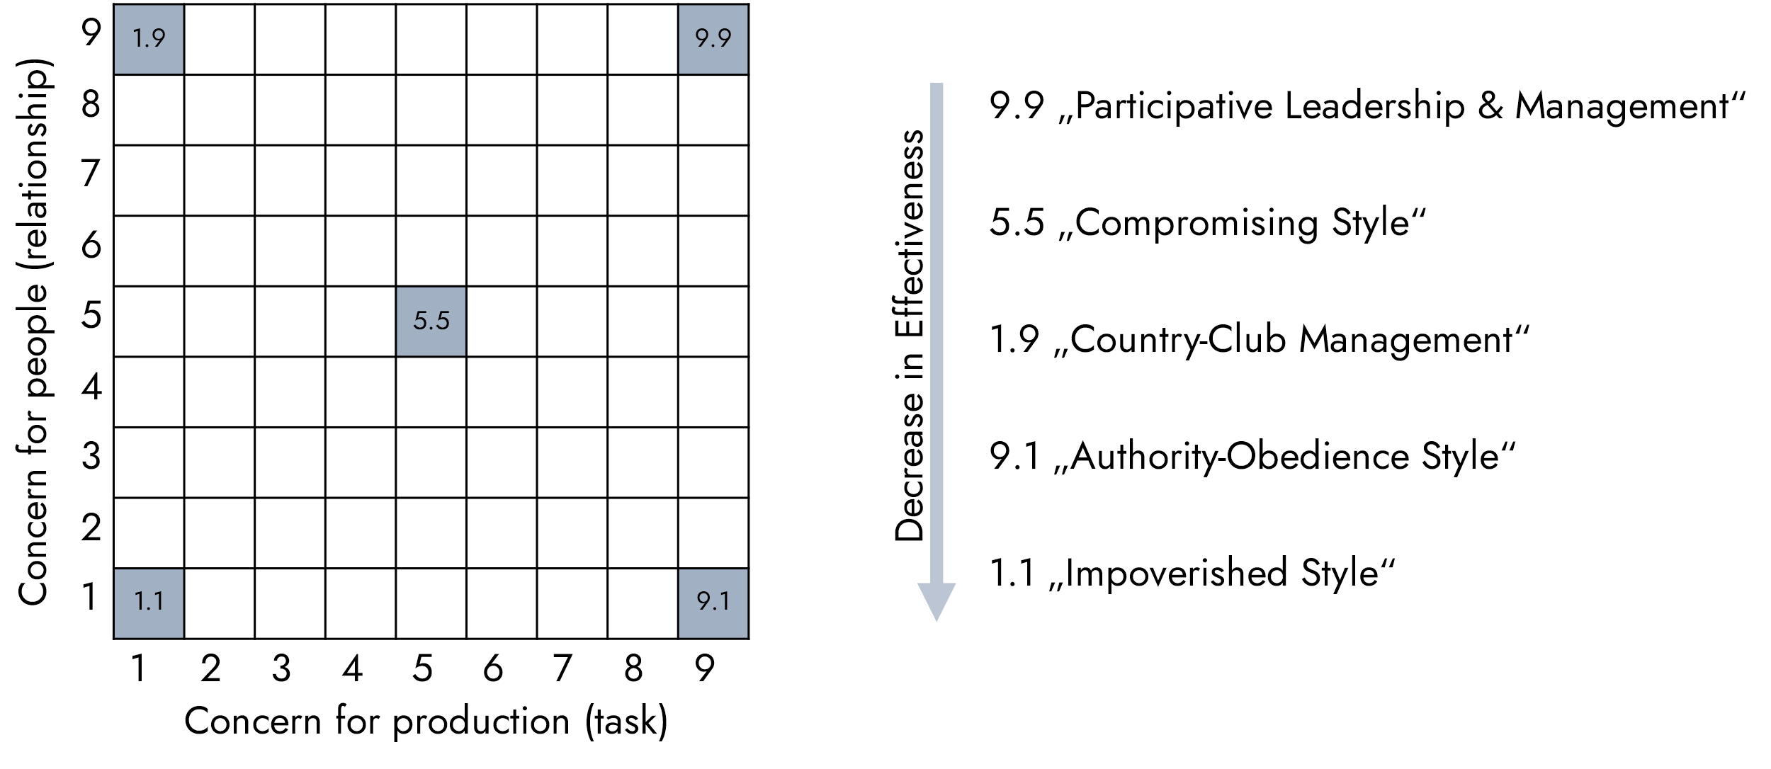

Figure 1: GRID-Model by Blake and Mouton; figure created by the authors.

The GRID-Model, developed by Robert Blake and Jane Mouton, is a management and leadership theory that portrays leadership styles based on two fundamental dimensions: concern for people (y-axis) and concern for production (x-axis). The model's grid consists of scores from 1 to 9 for each axis, resulting in a 9x9 grid. The numbers indicate the degree of emphasis a leader places on each dimension. For instance, a 1.1 leadership style implies low concern for both people and production, while a 9.9 style signifies high concern for both. Different combinations result in various leadership approaches, such as impoverished management (1.1), country club management (1.9), authority-obedience style (9.1), and participative leadership and management (9.9). The model aims to help leaders understand their own and others' leadership styles and make adjustments to improve their effectiveness. (Blake and Mouton 1964)

From the late 20th century onwards, contingent leadership trait theories have emerged. These include the **Contingency theory** of Fiedler. According to the understanding of these theories, leaders are successful if they know which leadership situation to choose, aligning their leadership style.

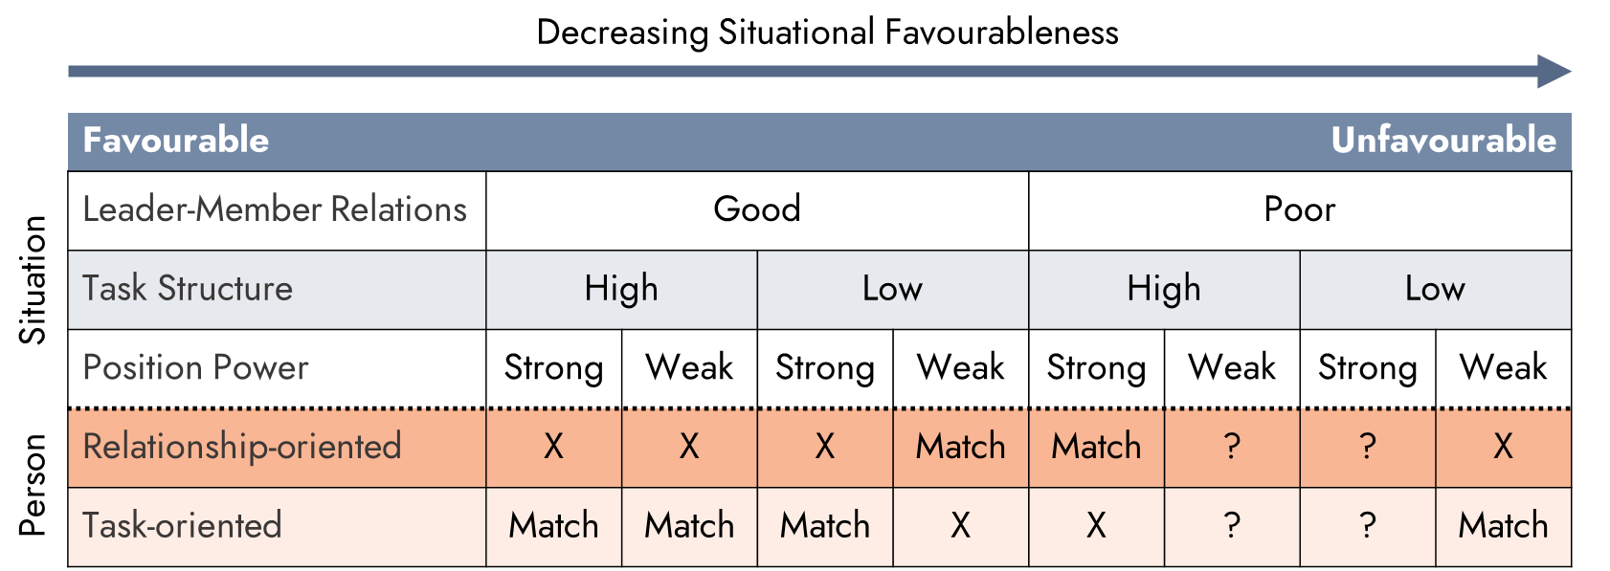

Figure 2: Fiedler's contingency theory; figure created by the authors.

Fiedler's Contingency Theory, developed by Fred Fiedler, proposes that effective leadership depends on the interaction between a leader's preferred leadership style (person) and situational favourability (situation). The theory categorises leaders as either task-oriented or relationship-oriented and assesses three situational factors: leader-member relations, task structure, and positional power. A leader's effectiveness is determined by matching their leadership style to the situation. For example, a task-oriented leader might excel in situations with high task structure and strong position power. In contrast, a relationship-oriented leader might match a situation with strong relationships, low task structure and weak position power. The theory emphasises that there is no universally effective leadership style and that a leader's effectiveness depends on the fit between their style and the situation. (Fiedler 1965; Jago 1982)

Lastly, contingent leadership behaviour theories occurred. Leaders of those theories are successful if they know how to adapt their leadership style to the situation at hand. The **Situational Leadership Theory** by Hersey and Blanchard is such a theory.

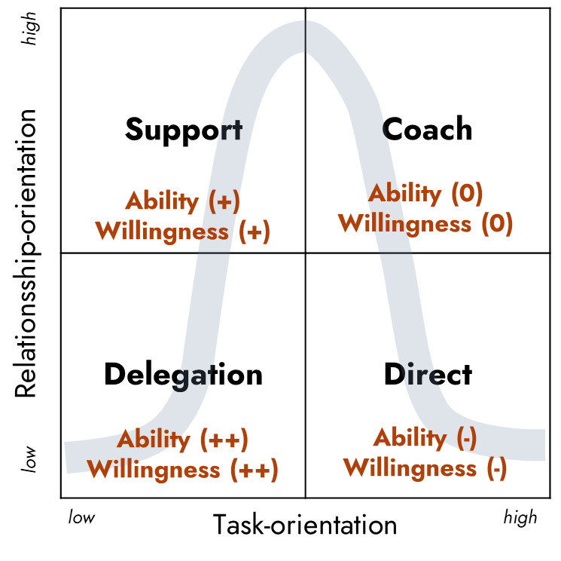

The Situational Leadership Theory, developed by Paul Hersey and Ken Blanchard, posits that effective leadership depends on adapting one's leadership style to the readiness level of their followers (psychological readiness = willingness & factual readiness = ability). The theory defines four leadership styles: directing, coaching, supporting, and delegating, which correspond to follower readiness levels: low ability and low willingness, some ability but variable willingness, moderate to high ability and willingness, and high ability and high willingness. Effective leaders adjust their approach, providing the appropriate level of direction and support based on the evolving readiness of their followers. This theory emphasises the need for flexible leadership to match the developmental stage of the followers and achieve optimal performance and growth. (Hersey and Blanchard 1977; Holtbrügge 2012)

Figure 3: Situational Leadership Theory by Hersey and Blanchard; figure created by the authors.

The subsequent dyadic and systemic leadership theories - as newer research approaches of the 21st century - clearly distinguish themselves from the initial, person-centred leadership theories. For example, dyadic theories such as leader-member exchange theory or transactional and transformational leadership focus on the exchange and relationship between leader and follower.

Although the more recent approaches are highly relevant for practice, the person-centred leadership theories are of particular interest for counselling female leaders. Since leadership theories emerged from their temporal context, the observed leaders of early leadership research were almost exclusively male. Therefore, the leadership characteristics surveyed are strongly biased toward the male gender, and the effects of this biased approach continue to be relevant.

* 1. New forms of leadership

Digitalisation has an impact on the way we work and what we work with (Hasenbein 2020). The *what* changes significantly due to the innovations of computer- and machine-supported technologies. However, the way of working is more relevant to counselling female leaders because it changes *how* leaders interact with their employees. Among the most significant effects on the *how* are new forms of collaborative work and more flexible work processes.

Traditionally, companies have been organised with hierarchical and rigid structures (Dincher and Scharpf 2018, p. 107). However, digitalisation poses the challenge of being able to react quickly and flexibly to changes in the environment (Schaff 2019, p. 312). Communication channels and cooperation patterns must become more direct and faster. Classic organisations can achieve this to a limited extent, which is why new organisational forms, such as agile or network-oriented organisations, are gaining relevance (Hasenbein 2020, p. 18). These forms share that communication at eye level is increasing, and cross-functional collaboration is being strengthened.

Internet collaboration makes work processes faster and more efficient. Several people can work on the same documents simultaneously, meetings do not require time-consuming travel, and data can be accessed anytime and anywhere. Among other things, this makes work more flexible in terms of time, place, and content. (Petry 2019, p. 45; Hasenbein 2020, p. 17)

Therefore, new forms of leadership emerge. Among those new forms of leadership are: Positive Leadership, Digital Leadership, Leader-Member-Exchange/Dyadic Leadership, Symbolic Leadership or Servant Leadership. The content of these leadership styles will be elaborated on in group work. For more information, please consult the references attached to this script.

* 1. Digital leadership
     1. Digital Leader and Digital Leadership

With the advancement of digital technology and the expansion of the digital environment, leadership approaches have to be rethought and reformulated. The new challenges of technology and digitalisation call for the emergence of a new type of leader, the digital one.  Digital leadership can be defined as the understanding and the use of digital technology to create value and achieve business goals. Irrespective of the function they are fulfilling at a company, digital leaders are those individuals who strategically use the company’s digital assets and technology to best fulfil business goals and keep an eye on the latest technological developments to make the best possible use of them and foster digital transformation. Digital leadership can also be understood at organisational level meaning a company which successfully uses its own digital technology to gain competitive advantage on the market.

Effective digital leaders incorporate digital innovations to the business model. As information technology develops, the digital leadership approach is becoming essential for understanding how emerging technologies work, using novel digital technologies to create a digital strategy for the company to work towards. If the digital leadership approach is systematically and thoughtfully applied, it will contribute to creating better awareness to the company’s brand and business processes, makes decision making informed and relying on data, helps creating better customer experience, and generally leads to improved business operations. According to study, digital leaders achieve 1.8 times higher earnings than those counterparts who are digitally lagging.

Digital leadership is essential for enterprises as it contributes to the success of digitalisation transformation procedures. A BCG study (Boston Consulting Group 2021) on the success of digital transformation across different sectors and industries found that 70% of digital transformation efforts fail to reach their objectives with sustainable results. 44% believe some value has been created with limited long-term change, and 26% regard the value created with no sustainability.

* + 1. Digital Leadership Competencies

Independent of concrete leadership theories, researchers are concerned with defining and classifying leadership competencies. This movement began in the 1970s with the psychologist David McClelland. McClelland was disturbed by the dominance of intelligence tests for determining leadership aptitude. He wanted to break up this one-sided focus with a broader perspective on all-encompassing leadership competencies. (McClelland 1973)

As with the definition of leadership, numerous approaches to the definition of leadership competencies have developed. These approaches have in common that leadership competence is composed of a cross-section of different competencies (Gigliotti 2019, p. 6). Competence is "an underlying characteristic of a person which results in effective and/or superior performance in a job." (Klemp 1980; cited after Chouhan and Srivastava 2014) These competencies include knowledge, skills, and qualifications, but also experience, values, norms, and motivation, as well as the general ability to cope with previously unknown, complex challenges. (Imbery et al. 2022, p. 99) Because of the generalised definition of competencies, some traits and skills from person-centred leadership theories are also found in competency models.

Trait theories are similar to competency models in that they attempt to describe the person who influences a group through their traits or competencies. Because competency models also initially examined predominantly male managers, the influences of gender distort the competency approach as well.

With digitalisation's impact on leadership, a leader's competency requirements are changing. In an integrative literature review, Ngayo Fotso (2021) compiles the competencies of a manager over time. The development of leadership competencies is outlined, starting with traditional leadership theories, followed by emerged leadership theories and finally supplemented by "21st century" theories. New leadership competencies of the 21st century are, on the one hand, the requirement of cooperation competencies and customer orientation and, on the other hand, adept digital competencies (Rybnikova and Lang 2021, pp. 395–396). Digital competencies - without reference to leadership - are described in the European Commission's "Digital Competence Framework for Citizens" (Vuorikari et al. 2022). The framework lists information and data competencies, communication and collaboration competencies, digital content creation, digital security and problem-solving skills as essential digital competencies. A similar picture emerges from van Laar et al. (2017, p. 583). In a systematic literature review, they identify information assessment and management, communication skills ("building," "sharing," "networking"), collaboration skills, as well as creativity, critical thinking, and problem-solving skills as "core 21st-century digital skills".

Although such general digital competency models cannot be equated with leadership competencies, they nevertheless reflect the changes in requirements arising from a digital (work) environment. It can be seen that both the feminine-associated, communicative future competencies and the masculine-associated technical skills, such as dealing with data, have become necessary.

Researchers who transfer these general digital competencies to the leadership context speak of digital leadership competence. Digital leadership competence is no longer just about the competence to lead but about the competence to lead digitally and in the context of digitalisation.

Therefore, digital leadership competence frameworks emerge continuously. Those are the subject of the group work and, therefore, not presented in detail here. For more information, please find the references attached to this script and presented in the presentation.

1. References

Bass, B. M. & Bass, R. (2008). Bass Handbook of Leadership: Theory, Research, and Managerial Applications (4th ed.). New York: Free Press.

Boston Consulting Group (2021). Which Sectors Perform Best in Digital Transformation? Online available under: <https://www.bcg.com/publications/2021/learning-from-successful-digital-leaders>, last accessed on the 21.09.2023.

Blake, R.R. & Mouton, J. S. (1964). The Managerial Grid: The Key to Leadership Excellence. Houston, Gulf Publishing.

Burns, J. M. (1978): Leadership (1st ed.). New York: Harper & Row.

Chouhan, V. S. & Srivastava, S. (2014): Understanding Competencies and Competency Modeling - A Literature Survey. In Journal of Business and Management 16 (1), pp. 14–22.

Dincher, R. & Scharpf, M. (2018): Management in der öffentlichen Verwaltung. Führung, Steuerung, Controlling (2nd ed.) Neuhofen (Pfalz): Forschungsstelle für Betriebsführung und Personalmanagement e.V.

1. Fiedler, F. E. (1965). Engineer the Job to Fit the Manager. Harvard Business Rev. 43 (5),115-122.

Gigliotti, R. A. (2019). An Introduction to Competencies and Competence-Based Leadership. In Ralph A. Gigliotti (Ed.): Competencies for effective leadership. A framework for assessment, education, and research (1st ed.). Bingley: Emerald Publishing, pp. 1–18.

Hasenbein, M. (2020). Der Mensch im Fokus der digitalen Arbeitswelt. Wirtschaftspsychologische Perspektiven und Anwendungsfelder. Berlin, Heidelberg: Springer.

Hersey, P. & Blanchard, K. H. (1977). Management of Organizational Behavior: Utilizing Human Resources. 3rd edition. New Jersey/Prentice Hall.

Holtbrügge, D. (2012). Personalmanagement (5th ed.). Berlin/Heidelberg: Springer Gabler.

Imbery, S.; Rowbotham, M.; Lindemann, M.; Gruninger-Hermann, C.; Schirmer, U. (2022): Digital-Leadership-Kompetenzkatalog. Mit den richtigen Kompetenzen die digitale Transformation gestalten. In zfo (2), pp. 98–104.

Jago, A. G. (1982). Leadership: Perspectives In Theory And Research. *Management Science* 28 (3), 315-336.

Klemp, G. O. (1980). The Assessment of Occupational Competence. Washington D.C.

Lippmann, E.; Pfister, A.; Jörg, U. (Eds.) (2019). Handbuch Angewandte Psychologie für Führungskräfte. Führungskompetenzen und Führungswissen. (5th ed.) Berlin, Heidelberg: Springer.

Lord, R. G.; Day, D. V.; Zaccaro, S. J.; Avolio, B. J.; Eagly, A. H. (2017). Leadership in applied psychology: Three waves of theory and research. In The Journal of applied psychology 102 (3), pp. 434–451. DOI: 10.1037/apl0000089.

Lord, R. G.; de Vader, C. L.; Alliger, G. M. (1986). A meta-analysis of the relation between personality traits and leadership perceptions: An application of validity generalization procedures. In Journal of Applied Psychology 71 (3), pp. 402–410. DOI: 10.1037/0021-9010.71.3.402.

Mann, R. D. (1959). A review of the relationships between personality and performance in small groups. In Psychological Bulletin 56 (4), pp. 241–270. DOI: 10.1037/h0044587.

McClelland, D. C. (1973). Testing for Competence Rather Than for "Intelligence". In The American psychologist 28 (1), pp. 1–14. DOI: 10.1037/h0034092.

Moore, B. V. (1927). The May conference on leadership. In Personnel Journal (6), pp. 124–128.

Nerdinger, F. W.; Blickle, G.; Schaper, N. (2019): Arbeits- und Organisationspsychologie. (4th ed.) Berlin, Heidelberg: Springer.

Ngayo Fotso, G. M. (2021). Leadership competencies for the 21st century: a review from the Western world literature. In European Journal of Training and Development 45 (6/7), pp. 566–587. DOI: 10.1108/EJTD-04-2020-0078.

Northouse, P. G. (2021). Leadership. Theory and practice (9th ed.). SAGE Publications.

Petry, T. (2019). Digital Leadership. Erfolgreiches Führen in Zeiten der Digital Economy (2nd ed.). Freiburg: Haufe.

Rybnikova, I.; Lang, R. (2021). Aktuelle Führungstheorien und -konzepte (2nd ed.). Wiesbaden, Heidelberg: Springer Gabler.

Schaff, A. (2019). Arbeit 4.0: Risiken für die psychische Gesundheit. In Burghard Hermeier, Thomas Heupel, Sabine Fichtner-Rosada (Eds.): Arbeitswelten der Zukunft. Wie die Digitalisierung unsere Arbeitsplätze und Arbeitsweise verändert. Wiesbaden: Springer Gabler, pp. 303–321.

Steyrer, J. (2015). Theorien der Führung. In Wolfgang Mayrhofer, Gerhard Furtmüller, Helmut Kasper (Eds.): Management-Seminar – Personal, Führung, Organisation (5th ed.). Wien, München: Linde, pp. 17–66.

Stippler, M.; Moore, S.; Rosenthal, S.; Dörffer, T. (2011). Führung - Überblick über Ansätze, Entwicklungen, Trends. Gütersloh: Verlag Bertelsmann Stiftung.

van Laar, E.; van Deursen, A. J.A.M.; van Dijk, J. A.G.M.; de Haan, J. (2017). The relation between 21st-century skills and digital skills: A systematic literature review. In Computers in Human Behavior 72, pp. 577–588.

Vroom, V. H.; Jago, A. G. (2007). The Role of the Situation in Leadership. American Psychologist 62 (1), 17-24.

Vuorikari, R.; Kluzer, S.; Punie, Y. (2022). DigComp 2.2: The Digital Competence Framework for Citizens - With new examples of knowledge, skills and attitudes. Publications Office of the European Union. Luxembourg (EUR 31006 EN).