READER

**CHANGE MANAGEMENT**

1 The importance of change management 2

2 Phases of change 2

2.1 Lewin's three phases of change 3

2.2 Vahs' integrative model 4

2.3 Kotter's eight-stage process 5

3 Responses to change 7

3.1 Mohr's and Woehe's type-model 7

3.2 Roth's phase model of emotional response 9

4 Five ways to deal with change 12

5 Main components of planned change 13

5.1 Outcomes 13

5.2 History 14

5.3 Actors 14

5.4 Phases of change 15

5.5 Communication and sense-making 15

5.6 Steering 17

References 18

Attachment 1 Diagnosis matrix 19

Attachment 2 Interventions matrix 20

* 1. The importance of change management

Change management is a structured approach to transition individuals, teams, and organisations from their current state to a desired future state. It involves planning, communicating, and implementing changes while minimising disruptions and maximising the stakeholder's buy-in. The process typically includes assessing the need for change, developing a clear strategy, communicating the rationale and benefits of the change, providing training and support, and continually evaluating and adapting the approach to ensure successful adoption. Effective change management ensures smoother transitions, reduces resistance, and enhances the likelihood of achieving desired outcomes. It might seem that change management is a one-time effort, but rather is a continuous process in which every attained success eventually becomes outdated.

Empowering women to strive for leadership will affect a company's culture, structure, and people within. Guidance professionals can impact these changes and whether their effects are positive or negative for everyone involved. Therefore, knowing about the fundamentals of change management is an important asset when providing guidance for (soon-to-be) female leaders. The following material describes phases of change and how to operate them, as well as reactions towards change and how to handle those.

* 1. Phases of change

Many theories and models provide a structure for the phases of change. Among the most prominent are the *three phases of change* by Kurt Lewin, the *eight-stage process* by John Kotter and an *integrative model* by Dietmar Vahs. All approaches have disparities and overlaps, and thereby also set a focus on the perspective from which they view change. Lewin provides a straightforward approach with three phases of change in which he predominantly describes the psychological level of impact. The integrative model by Vahs underpins these psychological aspects with the factual development of change phases from an organisational point of view. Kotter, however, focuses very much on the operational level of how to implement change effectively as a change facilitator. These three theories will be explained in the following passages.

* + 1. Lewin's three phases of change

Lewin's model (Lewin 1947) emphasises that change is not a one-time event but a process that involves preparing for change (unfreezing), implementing change (transition), and ensuring the change becomes a lasting part of the organisation (refreezing). His primary focus lies on decreasing resistance and emphasising the necessity for changing the status quo. Concretely, the phases are about:

Figure 1: Kurt Lewin's three phases of change. (Lewin 1947)



**LEWIN‘S THREE  
PHASES**

1. **Unfreezing:** The initial unfreeze Phase involves preparing individuals and the organisation for the upcoming changes by breaking down existing mindsets, behaviours, and processes. It involves creating awareness of the need for change and helping individuals and the organisation to understand why the change is necessary. By effectively executing the Unfreeze phase, organisations can overcome resistance to change and help individuals become more receptive and willing to embrace the upcoming transition. This sets the foundation for a smoother journey through the subsequent phases of the change process.
2. **Changing:** During this phase, the actual change is implemented. New processes, behaviours, or structures are introduced, and individuals begin to shift from their old ways to new ways of doing things. This phase can be characterised by uncertainty, resistance, and a period of adjustment as people learn and adapt to new conditions.
3. **Refreezing:** In the final phase, the changes are solidified and integrated into the organisation's culture and practices. This phase is about reinforcing the new behaviours, processes, or structures to ensure they become the new norm. By reinforcing the changes, individuals and the organisation become more stable in the new state, and the changes are more likely to be sustained over time.
   * 1. Vahs' integrative model

Dietmar Vahs is a German economist engaged in innovation management, organisational design, and change management. His integrative approach aims to consider and align various dimensions of change processes. It emphasises the need to holistically perceive changes within organisations and opt for a comprehensive approach. Therefore, it builds on Kurt Lewin's three mostly psychological phases and supplements them with a factual perspective of the organisation's tasks/phases (Vahs/Weinand 2013; Vahs 2019). The five phases of this approach are:

Figure 2: Vahs‘ integrative model of phases of change. (Vahs/Weinand 2013; Vahs 2019)

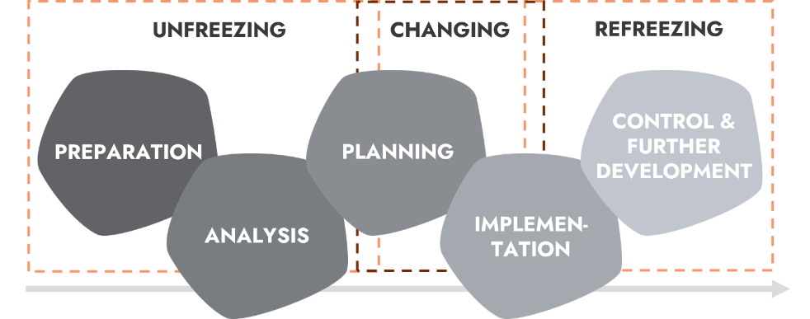

**Vahs‘   
intergative   
model**

1. **Preparation:** In this phase, the foundation for the change process is laid. The goal is to recognise and communicate the need for change, outline the vision for the desired future, and create readiness for change within the organisation. This involves identifying drivers and burdens triggering the change and creating awareness about the impending change.
2. **Analysis:** This phase comprehensively analyses the organisation and its current conditions. E.g., Strengths, weaknesses, opportunities, and threats (SWOT analysis) are assessed to gain a deeper understanding of the change requirements. The diagnosis lays the groundwork for developing a tailored change strategy and vision.
3. **Planning:** In this phase, the concrete change strategy is developed. This includes identifying actions, resources, and timelines necessary for implementing the change. It also entails defining clear goals and milestones to steer the change process.
4. **Implementation:**  In this Phase, the steps outlined in the planning phase are put into practice, often requiring close collaboration with involved employees and teams. Communication, training, and support are crucial in ensuring the acceptance and success of the changes.
5. **Control & further development:** After implementing the changes, it is vital to ensure that the new processes, structures, and cultural elements are integrated permanently. The stabilising phase involves monitoring outcomes, adjusting processes based on experiences, and solidifying the new practices as part of the organisational culture.
   * 1. Kotter's eight-stage process

John Kotter, a prominent leadership and change management expert, developed an eight-stage model for managing and leading successful organisational change (Kotter 2012; Kotter Inc. 2023). The eight-stage process can be perceived as a practical guide to handling the psychological level mentioned by Kurt Lewin rather than the factual level mentioned by Vahs. Thereby, it gives concrete notes on what to do from the perspective of a change manager. Therein, phases 1 to 4 reflect the Unfreezing phase, phases 5 to 7 map the Changing phase, and phase 8 is related to the Refreezing phase by Lewin. The eight stages are as follows:

Figure 3: Kotter's eight-stage process of change. (Kotter 2012; Kotter Inc. 2023)

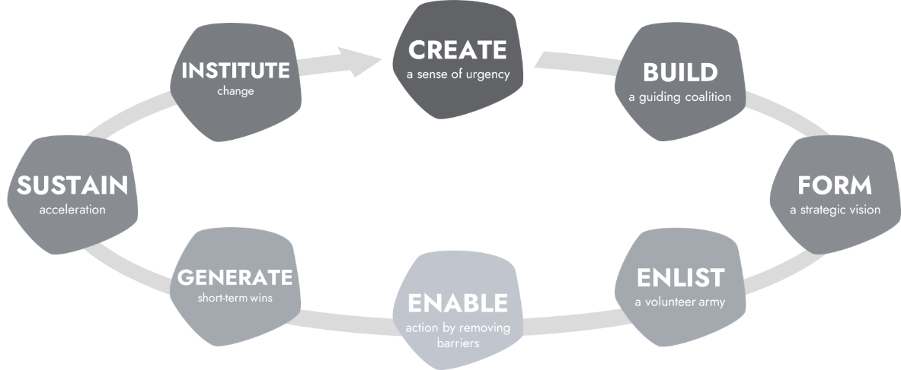

**Kotter’s eight-stage   
Process**

1. **Create a Sense of Urgency:** Present a compelling reason for the change. This involves creating awareness about the need for change by highlighting external pressures, market trends, or internal challenges that make the current state unsustainable. By conveying a sense of urgency, stakeholders can be motivated to take action and rally support.
2. **Build a guiding coalition:** Assemble a team of influential persons committed to the change initiative. This coalition should have the credibility and authority to guide the change process, communicate effectively, and overcome potential resistance. Therefore, its members should originate from various layers of the hierarchy and represent different organisational functions to ensure multiple perspectives and holistic information.
3. **Form a strategic vision:** Develop a clear and inspiring vision that outlines the organisation's desired future state after the change is implemented. This vision should be understandable, motivational, and aligned with the organisation's values and goals. Effectively communicate the change vision to all stakeholders. Thereby using various communication channels to enlarge the buy-in of all stakeholders.
4. **Enlist a volunteer army:** Gather and excite a sizable body of stakeholders, willing and enthusiastic to support the change initiative. Members of the organisation must be given a chance to participate in the process and have the autonomy to act for themselves. Recognising and encouraging the volunteers' efforts helps keep them engaged and recruit more.
5. **Enable action by removing barriers:** Enable and empower stakeholders at all levels to take action towards achieving the vision. This involves removing obstacles, providing the necessary resources, and giving individuals the autonomy to contribute to the change effort.
6. **Generate Short-Term Wins:** Celebrate and communicate small wins along the way. These (early) successes provide evidence that the change is making a positive impact and helps maintain momentum and enthusiasm among employees. The key is choosing achievable and regular milestones so that success becomes visible.
7. **Sustain acceleration:** Use the momentum from all the short-term wins to drive further change. This may involve tackling more complex challenges and making necessary adjustments based on feedback and experience.
8. **Institute change:** Ensure that the changes are integrated into the organisation's culture and way of doing things. This involves aligning new behaviours, practices, and processes with the organisation's core values and long-term goals.
   1. Responses to change

Dealing with these responses to change requires knowledge of the potential impacts and a flexible approach by leaders towards the behaviours exhibited. Therefore, a leader's role should adapt situationally throughout the change process and in interaction with the different response types and timelines.

* + 1. Mohr's and Woehe's type-model

The psychosocial perspective on change management was already described in Lewin's three phases. In addition to this temporal progression of emotions (Unfreezing, Changing, Refreezing), different types of reactions can be distinguished among employees. The types have different effects on the course of the change process and must, therefore, be differentiated and appropriately managed. A model for differentiating response types is the one by Mohr and Woehe, which provides both a comprehensible logic and an applicable structure (Nemeyer/Oltmanns 2010). The response types differ in how affected persons assess the risk of change impairing their own situation (subjective risk) and the general benefits of the change (objective risk).

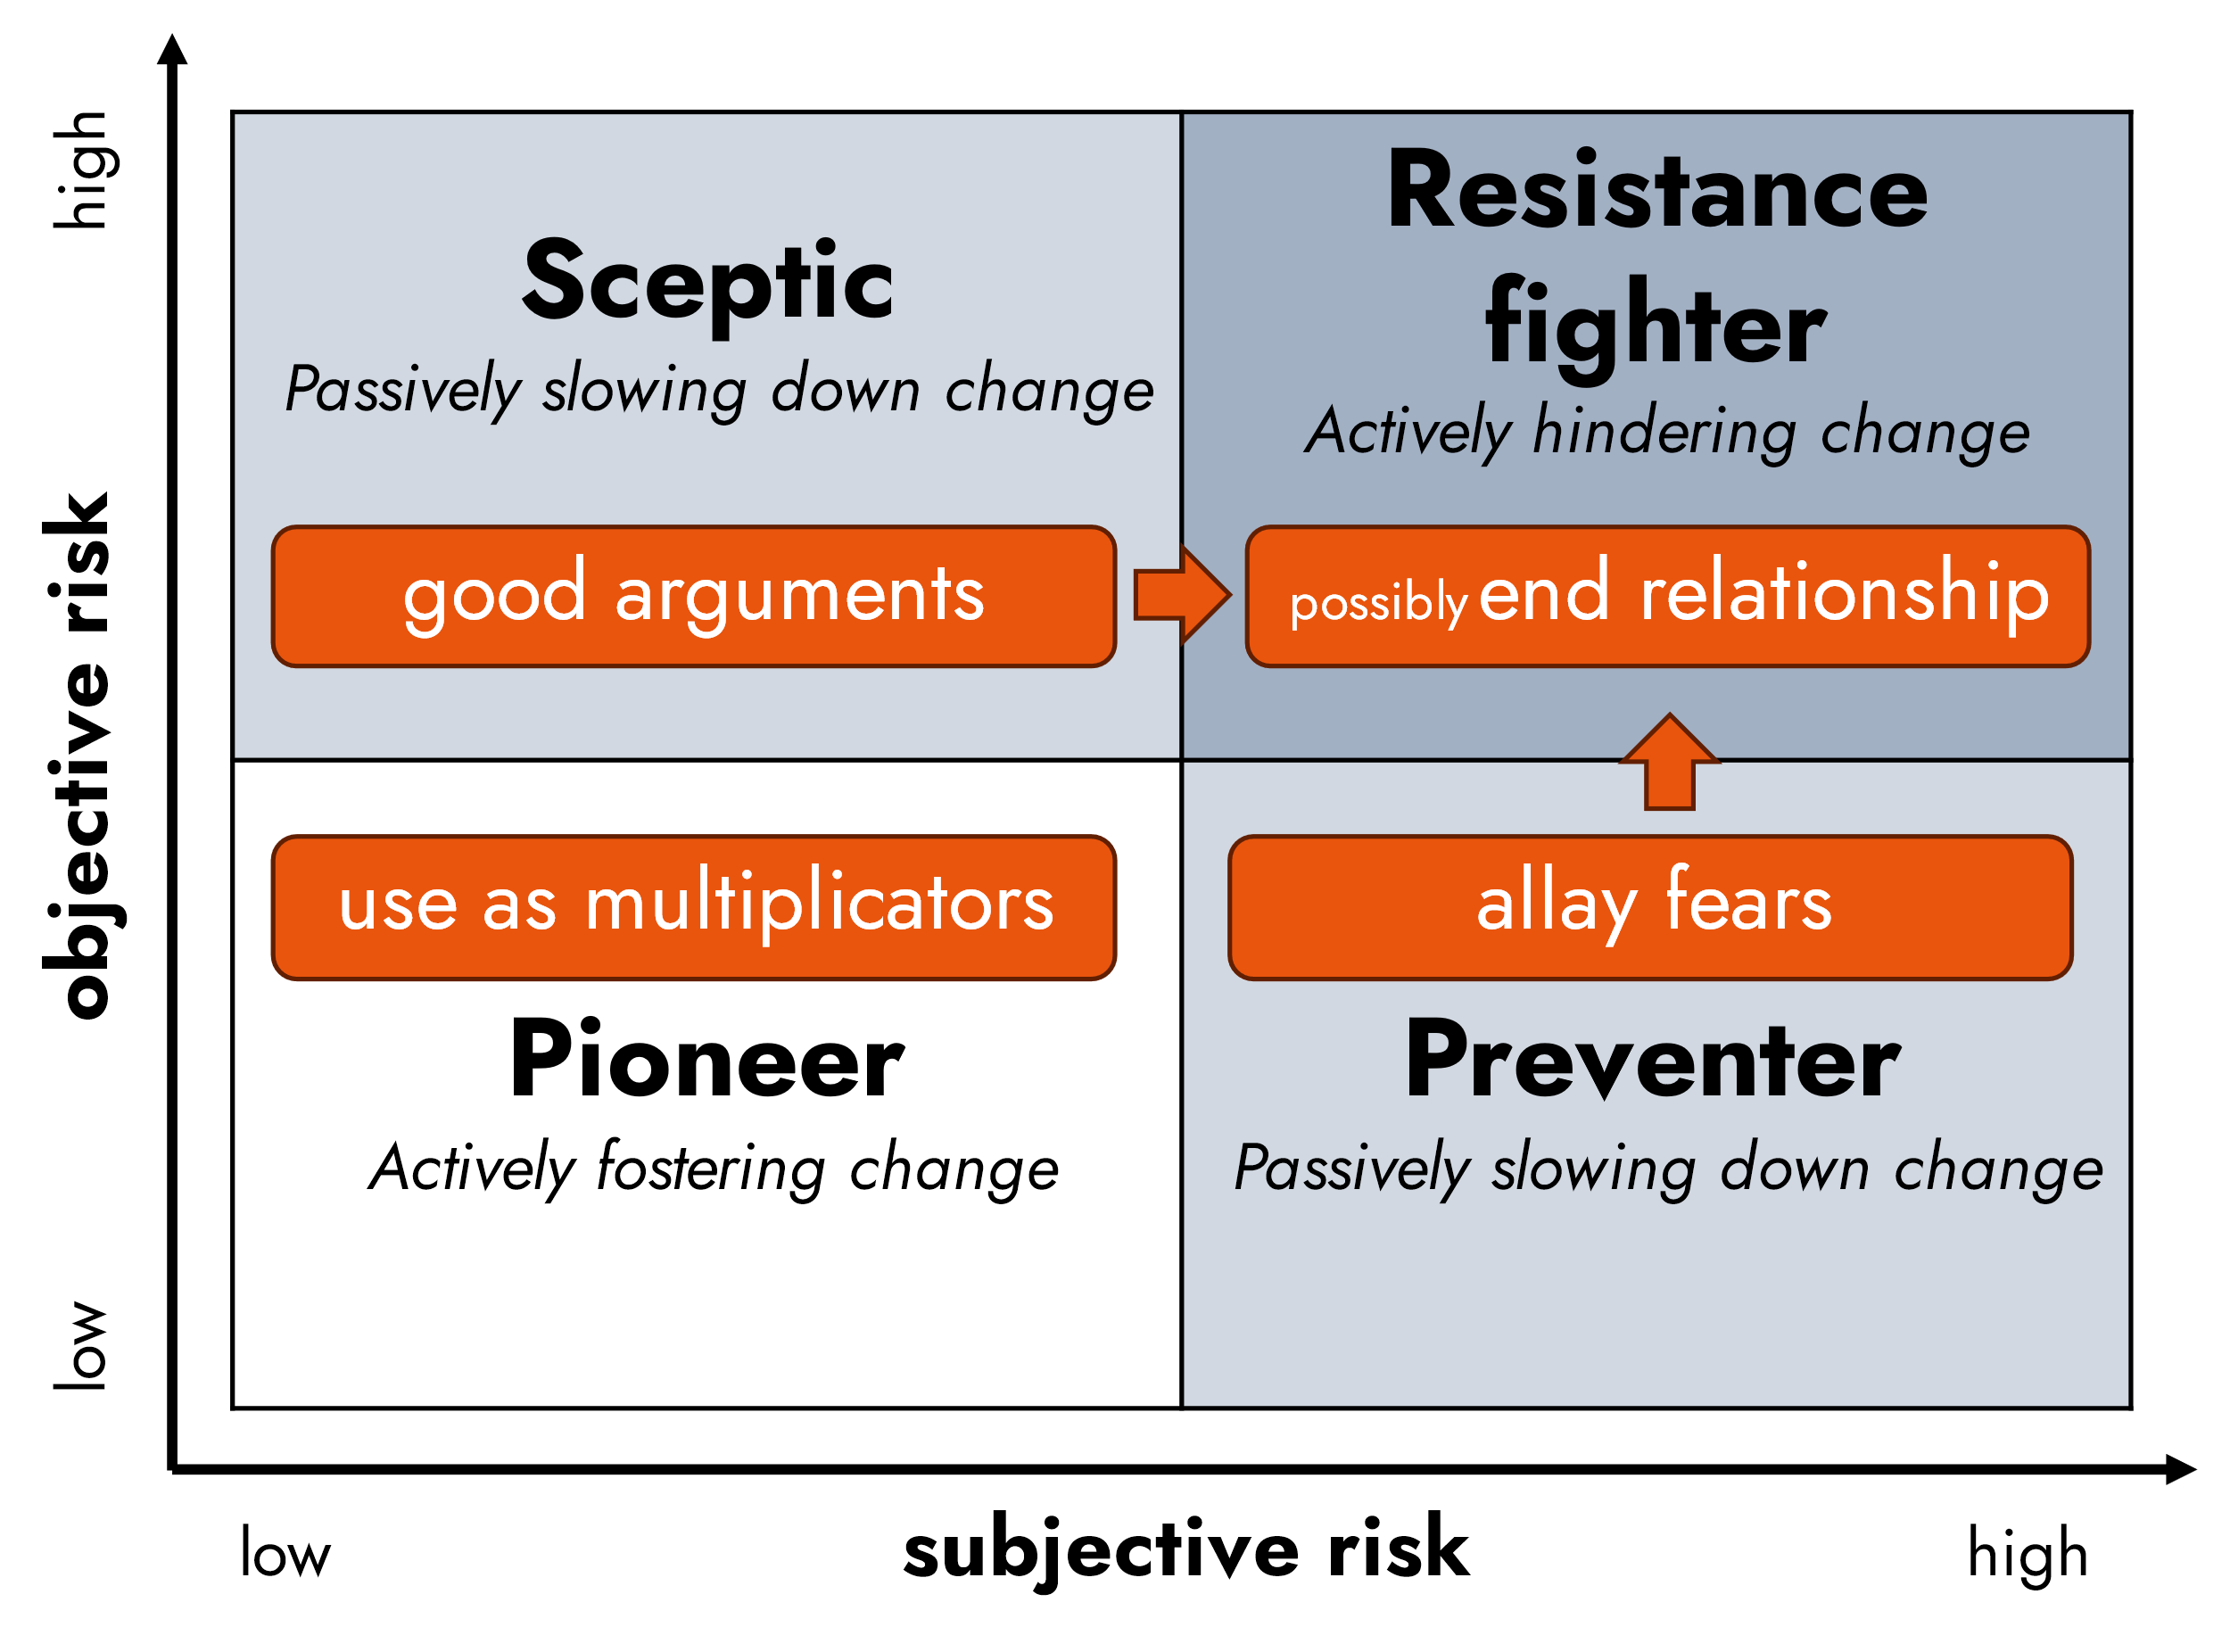

**Response   
Types By Mohr and WOEHE**

Figure 4: Response types to change by Mohr and Woehe. (Nemeyer/Oltmanns 2010)

* **Pioneers** see significant opportunities in the change and are willing to drive it forward actively. From a leadership perspective, such employees can be used as multipliers and actively involved in the initiative.
* **Sceptics** do not see a personal risk but, at the same time, do not see meaning in the intended change. They behave sceptically towards the change and do not contribute to its progress. Skilful rational argumentation from leadership can still persuade such employees of the benefits of the change initiative.
* **Preventers** see the change's benefits but, at the same time, have personal concerns about the outcome. While they support the change, their uncertainty prevents them from actively participating. Open communication and understanding of employees' emotions are helpful from a leadership perspective.
* **Resistance fighters** are not convinced by the change initiative from both a subjective and an objective perspective. Therefore, they actively resist the advancement of the changes, which could potentially hinder them. If such employees cannot be convinced otherwise (by allaying fears and presenting good arguments), an organisation must separate from them to avoid jeopardising the change's success.
  + 1. Roth's phase model of emotional response

Roth's phase model of emotional response to change describes seven emotional stages individuals can go through during a change process (Roth 2000; Rank/Scheinpflug 2008). It helps to better understand and manage psychological and emotional reactions to change. It is important to note that individuals experience those phases differently in terms of intensity and reside there for different periods of time. Also, the alterations in productivity depend on the success of the change management process. If done correctly, productivity still has ups and downs, but the extent of the productivity fluctuations is reduced. The seven phases and the according role of the facilitator are:

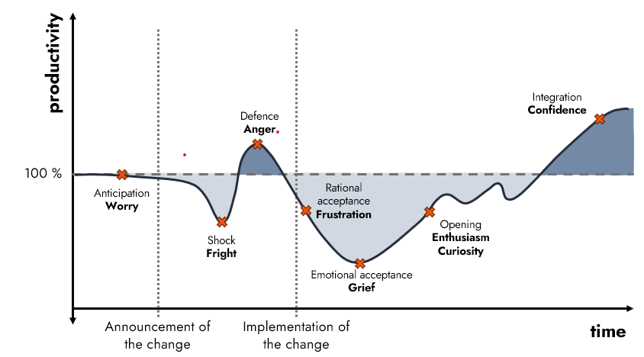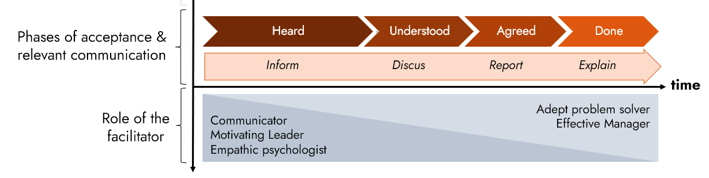

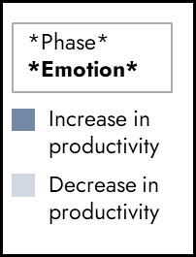

Figure 5: Response phases and interaction suggestions. (Roth 2000; Rank/Scheinpflug 2008; Jachtchenko 2021; Groth 2011)

1. **Anticipation:** The change has not yet been announced, but employees more than regularly suspect something will happen soon. This can lead to undesired rumours and anxiety amongst employees, which in turn might adversely affect the change realisation long term. To counteract negative effects, early and transparent communication is essential (Groth 2011). Leaders/Change facilitators should very much consider the fragile emotional situation employees might be in.
2. **Shock:** Once the (unsuspected) change initiative is announced, employees/other persons experience a shock. Something that has been known for a long time will be replaced by something that cannot be foreseen to its extent right at the moment. Therefore, productivity decreases. Like in the anticipation phase, it is essential to communicate effectively and to address the needs and concerns of those affected (Groth 2011).
3. **Defence:** Right after the shock phase, affected persons feel the urge to resist the upcoming change by proving the effectiveness of old actions and routines. Their engagement will lead to a brief increase in productivity. Facilitators should continue to inform about the necessity of the change initiative and should foster a sense of urgency (Groth 2011).
4. **Rational acceptance:** Rational acceptance develops once employees/other persons acknowledge that the announced change is inevitable. Affected persons feel frustrated about the situation and resign themselves to the new reality. Productivity decreases, especially for those who do not feel appropriately equipped – in terms of knowledge and skills – for their new tasks. Leaders/Change facilitators should act motivational and empathic and also help to understand the change necessity and, therefore, discuss it (Groth 2011).
5. **Emotional acceptance:** Emotional acceptance is the tipping point. Employees realise that routines and habits have to change. Self-esteem is at its lowest point at this moment, and therefore, productivity is as well. On the other hand, the willingness to try new things begins to form and leads to the next phase. As before, leaders/change facilitators should act motivational and empathic and also help to understand the change necessity by discussing it (Groth 2011).
6. **Opening:** Employees/other persons become open to testing new routines and the results of the change. They are interested in the advancements and, therefore, willing to adapt to the new routines. However, it takes a few test rounds to get things right, which is why productivity wobbles during this phase. Keeping everyone involved and motivated is crucial, so reporting and celebrating short-term success and sustaining acceleration is needed (Groth 2011).
7. **Integration:** Finally, employees/other persons embrace the change outcome and can act within the new structure. Productivity increases; if the change is planned well, value is added and productivity exceeds the old level. In terms of communication, there should be a lot of explanations to help employees/other persons learn and continuously learn new skills (Groth 2011).

While describing those phases of emotional reaction, it becomes clear that Kotter already addresses some of the communication tasks with his model. However, Kotter's model also includes organisational tasks that are not directly relevant to communication (e.g., enlist a volunteer army).

The role of the change facilitator leans on a book by Wladislaw Jachtchenko, in which he describes five roles of a leader (Jachtchenko 2021). Although his book specifically addresses leadership behaviour – not guidance counselling – the idea behind those roles is still relevant to understanding how change processes are handled. The roles are:

* **Communicator:** being charismatic and persuasive; using rhetorical methods to convince; having good arguments.
* **Effective manager:** being effective and efficient; focusing on output and outcome rather than interpersonal aspects.
* **Motivating leader:** being motivational and enthusiastic; adapting motivational techniques to each and every individual's needs.
* **Empathic psychologist:** being empathic and supportive; addressing the individual character of every employee.
* **Adept problem solver:** being rational and solution-orientated; focusing on situations and their factual level.
  1. Five ways to deal with change

There is a world of difference between the underlying assumptions of the various strategies or approaches that are applied to change. As a result, the practical applications of these strategies also vary. De Caluwé and Vermaak (2003; 2018; 2019) aim to define five distinct ways of thinking about change within organisations, things or people: yellow-print thinking, blue-print thinking, red-print thinking, green-print thinking and white-print thinking.

Table 1 summarises the five ways of thinking, including their main assumptions and keywords.

|  |  |  |  |
| --- | --- | --- | --- |
| **The colour print model** | **Assumptions** | **Things/people will change if you…** | **Keywords** |
| Yellow-print thinking | Something only changes when key players are backing it. Enabling change requires getting the powers that are behind it, whether their power is based on formal positions (e.g. board members) or informal positions (e.g. opinion leaders). | … Unite the interest of important players / compel people to accept (common) points of view / create win-win situations / form coalitions | Power Politics |
| Blue-print thinking | Change only happens when you analyse the problem, suggest the best possible solution and implement it according to plan. Change is thus deemed a linear endeavour: you think before you act. | … Formulate a clear goal beforehand / lay down a concrete plan with clear steps / monitor the steps well and adjust accordingly / keep everything stable and controlled / reduce complexity | Rationality Structure |
| Red-print thinking | Change is not about policies and plans but about behaviour. People only change their behaviour when they are stimulated to do so, for example, by rewarding them or offering support. | … Stimulate people in the right way / employ advanced HRM tools / give people something in return / manage expectations / create a good atmosphere / make change attractive | Motivation Social |
| Green-print thinking | Changing and learning are deemed inextricably linked: they are thought to mean almost the same. The only way forward is to dig deeper, discover one's limits and expand and deepen the way we see and act in the world | … Make people aware of new insights / motivate people to learn new things / create collective learning situations / allow people to gear towards learning goals | Learning Growing |
| White-print thinking | Change is constant and takes place of it's own accord. People can make the most difference when they understand and catalyse a change that is about to happen. Evolution is not created but supported (or obstructed). | … Start from people's drives and strengths / add meaning to what people are going through / remove obstacles / give free rein to people's energy / make use of rituals | Organic Evolution |

* 1. Main components of planned change

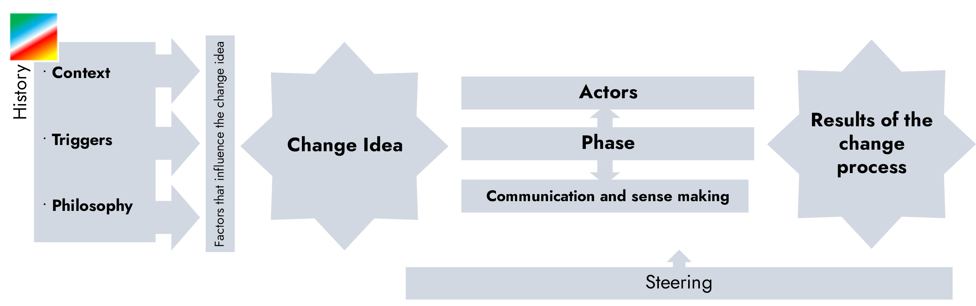

Chapter 5.3 – 5.5

Chapter 5.1

Chapter 5.2

Chapter 5.6

Adjusted and used from: De Caluwé, L., & Vermaak, H. (2003). *Learning to change: A guide for organisation change agents.* SAGE Publications, inc.

"Planned change is about realising **the intended outcomes**, while recognising and building on **the historical context**, by **actors** who influence each other, by going through a sequence of **phases** or steps, by **communication and sense-making**, while the change process is **monitored and guided** by change agents."

* + 1. Outcomes

Change can be regarded as the realisation or facilitation of intended outcomes. The following model (Figure 1) can be used to clarify and identify these outcomes. This model divides possible outcomes into five separate sets of characteristics, namely:

* **Characteristics of products, services and operations** (e.g. flexibility, efficiency, quality, effectivity, rentability, etc.)
* **Characteristics of interaction** (e.g. openness, respect, initiative & action, learning ability, inspiration, vitality, collective ambitions, etc.)
* **Characteristics of people** (e.g. skills, power, willingness, knowledge)
* **Characteristics of organisation and management** (e.g. structure culture, management style, systems, etc.)
* **Characteristics of business processes** (e.g. R&D, production, marketing & sales, evaluation & aftersales, HRM, finance, logistics, planning, etc.)

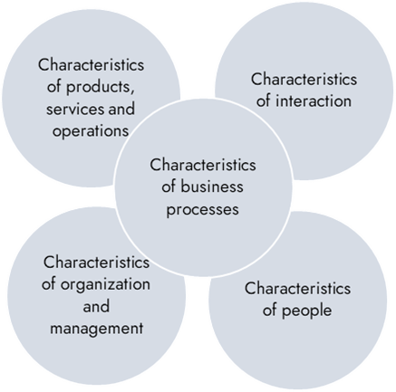Figure 1. Model for identifying desired outcomes. Adjusted and used from: Vermaak, H., & De Caluwé, L. (2019).  *Leren veranderen: Kennis voor veranderaars in opleiding en praktijk* (Derde, geheel herziene editie). Deventer; Vakmedianet.

The generalised model helps to brainstorm about desired outcomes, reflect on and reframe outcomes, reduce bias and explore the interconnectedness between characteristics. It aids discussion about what should be regarded as means and what as ends.

* + 1. History

Planned change does not start by itself; there must be an engine or source. Three things fuel this engine:

1. **The context:**

Characteristics of the organisation and things around the system

(history, branche/sector, competition, society, etc.)

1. **The trigger:**

emotional characteristics

(ambition, dissatisfaction, conflict, imbalance, etc.)

1. **The philosophy:**

meaningful characteristics that form the basis of the change idea

(vision of people, values, political beliefs)

* + 1. Actors
* Initiators: launch the change idea and put it on the agenda
* Sponsors: use their formal and informal powers to legitimise or tolerate the change idea
* Orchestrators: set up the change, stimulate implementation and monitor progress
* Supporters: informally support the idea and make it known
* Champions: participate in coordinating the implementation plan
* Implementers: realise the change interventions on the work floor
* Victims: undergo the change on the work floor (happily or unhappily)
  + 1. Phases of change

In defining the phases of change, the authors have opted for a simple four-way split that seems to be applicable to all colours of change (see Figure 2). Of course, the activities within the change phases are not a continuous, homogenous stream.

**Diagnosis**

**Change**

**strategy**

**Intervention plan**

**Interventions**

In this document, we won't discuss the different phases in depth. However, the attachments present an example of a diagnostic matrix (attachment 1) and an intervention matrix (attachment 2).

* + 1. Communication and sense-making

Communication and sense-making are crucial in change processes. Communication and sense-making can be done **about the change** and **within the change**. Communication about the change is done to inform and inspire people in the organisation and the outside world. Communication within the change is done to make the change successful, for example, by discussing the contents of the change or motivating other people to participate.

A few examples of resources for communication are presented in Table 2.

|  |  |
| --- | --- |
| **The colour print model** | **Resources** |
| Yellow-print thinking | **Resources to find out what's going on in organisations**   * Formal and informal consultations, work sessions * Consultation meetings * Expert sessions * Opinion influencing media * Lobbying/ leakage |
| Blue-print thinking | **Parallel media informing everyone at the same time**   * Newsletters/ brochures/ staff magazines * Intranet and other electronic resources * Audiovisuals (film) * Charts, progress meters, models * Staff meetings |
| Red-print thinking | **Resources that promote face-to-face communication**   * Staff interviews, work meetings * Personnel instruments * Goodies (rewards) * Planned imaging through internal media |
| Green-print thinking | **Resources that engage employees by experimenting and learning**   * Discussion and feedback on functioning * Peer review * Trainings, gaming simulations * Communication through role-models |
| White-print thinking | **Resources that promote open communication**   * Viral messages * Voices of dissent from people who disagree * Group discussions * Brainstorming sessions |

* + 1. Steering

Without steering, the change process is like a 'runaway train' without a machinist. Steering means using feedback- and feedforward cycles to assess the progress, reconsider the outcomes and (re)plan the process. You can do this by answering the following three questions:

What has happened so far, and what is happening now?

Are we still willing and able to realise what we set out to do?

How do we continue, and what are our intentions at this point?

1. References

De Caluwé, L., & Vermaak, H. (2003). *Learning to change: A guide for organisation change agents*. SAGE Publications, inc.

Groth, A. (2011). Führungsstark im Wandel. Change Leadership für das mittlere Management (1. Ed.). Frankfurt a. M.: Campus.

Jachtchenko, W. (2021). Die 5 Rollen einer Führungskraft (2. Ed.). Oakland Park: Remote Verlag.

Kotter, J.P. (2012). Leading Change. Harvard Business Review Press, Boston.

Kotter Inc. (2023). The 8 Steps for Leading Change. https://www.kotterinc.com/methodology/8-steps/, last checked 24.07.2023.

Lewin, K. (1947). Group Decision and Social Change. In T. Newcomb & E. Hartley (Ed.), Readings in Social Psychology (p. 197–211). New York: Holt, Rinehart & Winston.

Nemeyer, D. & Oltmanns, T. (2010). Machtfrage Change. Warum Veränderungsprojekte meist auf Führungsebene scheitern und wie Sie es besser machen. Frankfurt, M.: Campus.

Roth, S. (2000). Emotionen im Visier. Neue Wege des Change Managements. Organisations Entwicklung 2 (02), 14-21.

Rank, S. & Scheinpflug, R. (2008). Change Management in der Praxis (2. Ed.). Berlin: Erich Schmidt.

Vahs, D. & Weiand, A. (2013). Workbook Change Management. Methoden und Technik (2. Ed.) Stuttgart: Schäffer-Poeschel.

Vahs, D. (2019). Organisation. Ein Lehr- und Managementbuch (10. Ed.). Stuttgart: Schäffer-Poeschel.

Vermaak, H., & de Caluwe, L. (2018). The Colors of Change Revisited: Situating and Describing the Theory and its Practical Applications. 10.1108/S0897-301620180000026005.

Vermaak, H., & De Caluwé, L. (2019).  *Leren veranderen: Kennis voor veranderaars in opleiding en praktijk* (Derde, geheel herziene editie). Deventer; Vakmedianet. **(Only available in Dutch)**

Attachment 1 Diagnosis matrix

|  |  |  |  |  |
| --- | --- | --- | --- | --- |
| **The colour print model** | **Individual** | **Group** | **Organisation** | **Environment** |
| Yellow-print thinking | 1. Does this person know what is going on in the organisation?  2. What is this person's real agenda?  3. Is this person somewhat well-liked by the board? | 1. Who talks to who and who doesn't?  2. Are there people wearing two hats?  3. Who is leading and what is his room for manoeuvre? | 1. What are the chances of reaching an internal consensus? 2. Who are the (informal) leaders? 3. What does the headquarters want? | 1. How is corporate governance organised? 2. Who poses our biggest threat? 3. Are there rules and regulations that influence this? |
| Blue-print thinking | 1. What are the tasks and responsibilities of this person? 2. What does this person know and what do they not know?  3. What colour does this person have? | 1. What are the decision-making rules?  2. What is the span of control?  3. In which phase are we? | 1. What does the organisational chart look like? 2. Are we still making a profit and staying on track? 3. What are we basing that on? | 1. Who are the competitors and what is their market share? 2. Who are the chain partners? 3. Is it possible to operate using a franchise model? |
| Red-print thinking | 1. Is this person a team player?  2. What does this person get excited about?  3. Is this person loyal? | 1. Is there a good working atmosphere?  2. Do people get along with each other?  3. Are people collaborating? | 1. What is the organisational culture like?  2. What ambitions are being pursued?  3. Is there a Christmas tree (during Christmas)? | 1. What image do we have in the outside world?  2. Are we good neighbours in the region?  3. How is the consumer satisfaction? |
| Green-print thinking | 1. Does this person reflect on themselves?  2. Does this person push their limits?  3. Is this person aware of what annoys him? | 1. Do people confront each other?  2. Are people experimenting?  3. Do people complement each other? | 1. How are experience and knowledge preserved?  2. Are people learning on the job?  3. Do office doors stay open? | 1. Do we listen to customers?  2. Do we respond to external trends?  3. Do we gain and use scientific knowledge |
| White-print thinking | 1. Does this person make their work exciting?  2. Does this person know what they want?  3. Can this person handle conflicts? | 1. Can people find humour in it?  2. Is diversity actively sought after?  3. Is it a coincidence that this group has formed? | 1. What is holding people back?  2. What are the roots of the organisation?  3. What motivates people? | 1. Do we have a message for the outside world?  2. How do we define our world?  3. How central do we perceive ourselves in the network? |

Attachment 2 Interventions matrix

This matrix contains examples of interventions and modes of behaviour that can be implemented during the execution of an intervention plan.

An intervention is defined as *one or a series of planned change activities aimed at increasing (or helping to increase) the effectiveness of an organisation*. Thus, interventions can be directly and/or indirectly supportive in reaching the desired outcomes.

|  |  |  |  |
| --- | --- | --- | --- |
| **The colour print model** | **Individual** | **Group** | **Organisation** |
| Yellow-print thinking | 1. Personal commitment statement  2. Outplacement  3. Protégé-constructions | 1. Confrontation meetings  2. Third-party strategy  3. Top structuring | 1. Improving the quality of work life  2. Forming strategic alliances  3. Negotiations on labour conditions |
| Blue-print thinking | 1. Management by objectives  2. Hygienic working  3. Working with a day planner | 1. Working in projects  2. Archiving  3. Decision making | 1. Strategy analysis  2. Business process redesign  3. Auditing |
| Red-print thinking | 1. Career development 2. Recruitment and selection  3. Job enlargement / enrichment | 1. Social activities  2. Team roles  3. Management by speech | 1. Reward systems  2. Managing mobility and diversity  3. Triple ladder |
| Green-print thinking | 1. Coaching  2. Intensive clinic  3. Feedback / mirroring | 1. Team building  2. Gaming  3. Intervision | 1. Open systems planning  2. Parallel learning structures  3. Quality circles |
| White-print thinking | 1. T-group  2. Personal growth  3. Networking | 1. Self-steering teams  2. Open-space meetings  3. Making mental models explicit | 1. Search conferences  2. Rituals and mystique  3. Deconstructing "sacred cows" |